www.Skyrocketon.com / Facebook OffclSkyrocket / Instagram @OffclSkyrocket / Twitter @OffclSkyrocket

Blume
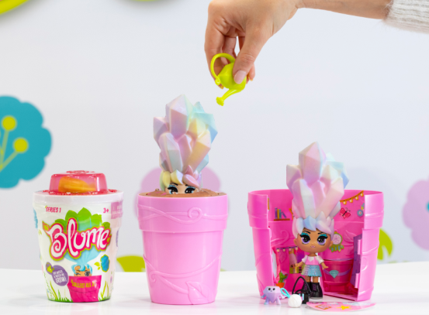
From the creators of Pomsies, the #1 selling special feature plush in 2018 according to NPD, comes Blume – dolls that mix imaginative, over-the-top hairstyles with an awesome blooming effect for a surprising toy “reveal” experience! Use the included watering can to add water onto the “seeds”, wait a few seconds, and watch as your Blume doll starts to grow—right out of her flowering pot! As her unique hairstyle emerges, you’ll be able to recognize which Blume character you have. Twenty-two dolls will launch in this summer’s first collection and be categorized by rarity: “adorable”, “rare”, “super rare”, and only one “mystical” doll. Each doll blooms bigger than her pot and comes with an outrageously-hip hairstyle, adorable outfit, handbag, cute mini friend, and sticker book. Collect them all to mix-and-match hairstyles, outfits and accessories! Blume dolls are the next best collectable with an ultimate reveal package—not to mention, no unnecessary pieces or extra trash is generated from the fun! Ages 5+, SRP $9.99, www.BlumeDolls.com Available at major retailers in July

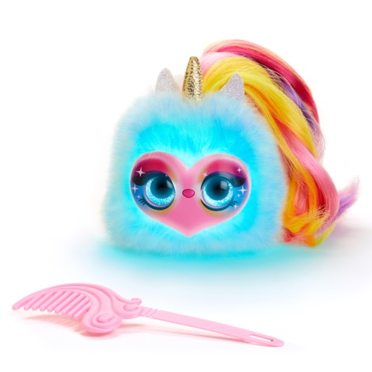
Pomsies Lumies
Pomsies Lumies are the next generation of Pomsies, the #1 selling special feature plush in
2018 according to NPD, but with a rainbow charged twist. These cute and interactive
unicorn-like pets can turn into any color: simply place Pomsies Lumies on an object and it
will magically absorb that object’s color and shine bright! Use this color-matching play
pattern to nurture your Pomsies Lumies (more colors means a happier pet!), coordinate
your outfits, or play a number of games such as Memory and Whack-A-Mole. Pomsies
Lumies will react differently depending on their mood and the colors you find—over 50
sounds and phrases! For added fun, enter into Music Mode where beats and melodies are
pulled out of everyday objects through color. Choose from 3 Pomsies Lumies characters—
Sparkle Rush, Pixie Pop, and Dazzle GoGo—each as vibrant as the next with their own
Unique look and sound. Ages 3+, SRP $19.99 www.Pomsies.com
Available at major retailers in July
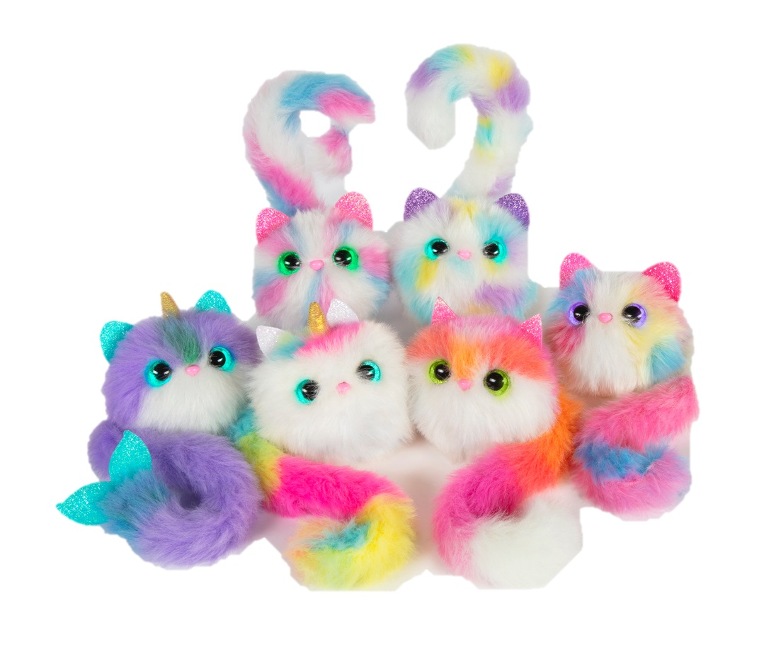
Pomsies Wave 4
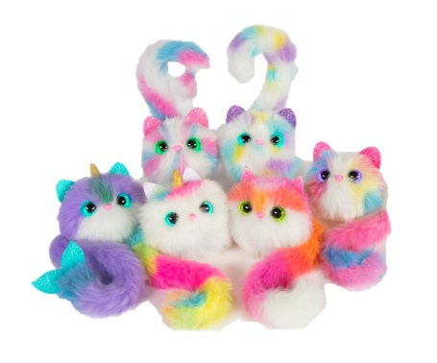
Wave 4 of Pomsies, the #1 selling special feature plush in 2018 according to NPD, is here
with all new characters, sounds, and features! Wave 4 introduces Bubbles the narwhal, Luna
the unicorn, Trixie the fox, and Sherbert, Peppermint and Funfetti the trio of cats. These
lovable, wearable pom-pom companions offer two modes of play: Virtual Pet Mode and Freeze
Dance Mode, the latter of which lets you and your friends play together. Pomsies will tell you
when they are feeling happy, sleepy, or hungry with eyes that light up in different colors and
adorable sounds. Plus, their ears are more sparkly than ever! When you pet one of three touch
points on their head, nose, and mouth, Pomsies will react with up to 50 different responses.
Nurture your Pomsie long enough and you will be rewarded with colorful rainbow eyes and
sweet, cuddly sounds. Additionally, thanks to their wrap-around tail, Pomsies can go anywhere
you go! Ages 3+, SRP $14.99 www.Pomsies.com Available at major retailers in July

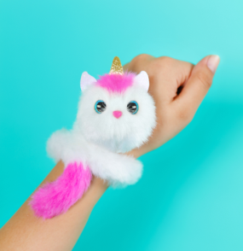
Pomsie Poos
Your favorite Pomsies are now in miniature size! Pomsie Poos are ultra-cute, smaller-sized
Pomsies plush without the electronics features but still have the long wrap-around tail to take and wear anywhere – it’s the perfect accessory! A heart-shaped clasp also attaches to backpacks, clothing and more. Pomsie Poos are highly collectible with 12 adorable animal characters to collect in the first waves, including cats, dogs, pandas, foxes, koalas, bats, raccoons and more.
Ages 3+, SRP $4.99, www.Pomsies.com; In Stores Now

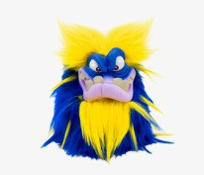
Grumblies
Erupting from the Earth’s core, watery caves and fiery pits are Grumblies™ interactive plush creatures
– be careful, don’t make them meltdown! If you push them too far by poking, shaking and flipping them on their heads they’ll go into a rumbling seismic meltdown and only you can calm them down! Each
Grumblie has over 40 sounds and reactions. Tremor is a mean green seismic machine, Scorch sets
off volcanic rings of fire, Bolt shoots electrifying bursts of solar energy into the air, and Hydro can rumble up a tsunami when provoked. New for Spring is the Walmart exclusive Mojo Grumblie with magical powers and vibrant blue and yellow hair! Grumblies was included on Amazon’s Top 100 Toys of 2018 list. Ages 5+ SRP $19.99, www.GrumbliesMeltdown.com; In Stores Now
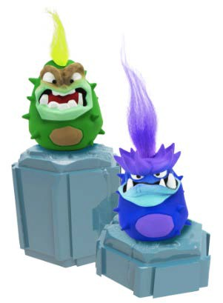

Grumblies Miniacs
Take your Grumblies everywhere you go with the new Grumblies Miniacs - miniature versions of the popular Grumblies characters. Grumblies Miniacs are as grumpy as the bigger version with highly detailed, lively facial expressions and colorful, shapeable hair. Miniacs can be thrown on the end of your pencils, in your backpack or displayed on your shelf with packaging that gives you the ability to stack and
display. Grumblies Miniacs are collectible with 12 different styles that come in individual blind packs.
Ages 5+, SRP $3.99, www.GrumbliesMeltdown.com

About Skyrocket
Skyrocket is a leading toy and entertainment company defining the future of play. Leveraging the latest innovations in the industry, our groundbreaking product portfolio is changing the way consumers engage and interact across generations. Our team of entrepreneurs, product developers and design engineers pioneer new ideas in toys, retail and entertainment to elevate play and advance the industry.

With offices in Los Angeles, Hong Kong and the United Kingdom, Skyrocket creates products sold under major licenses as well as proprietary brands including Blume, Pomsies, Grumblies and Sky Viper Drones.

Skyrocket LLC Los Angeles, CA 90066 USA / Skyrocket is a trademark of Skyrocket LLC

