Petooties Pets™
Adopt Them All! All new collection of mini plush animals from Russ

VIEW AND DOWNLOAD HIGH-RES PRODUCT IMAGES
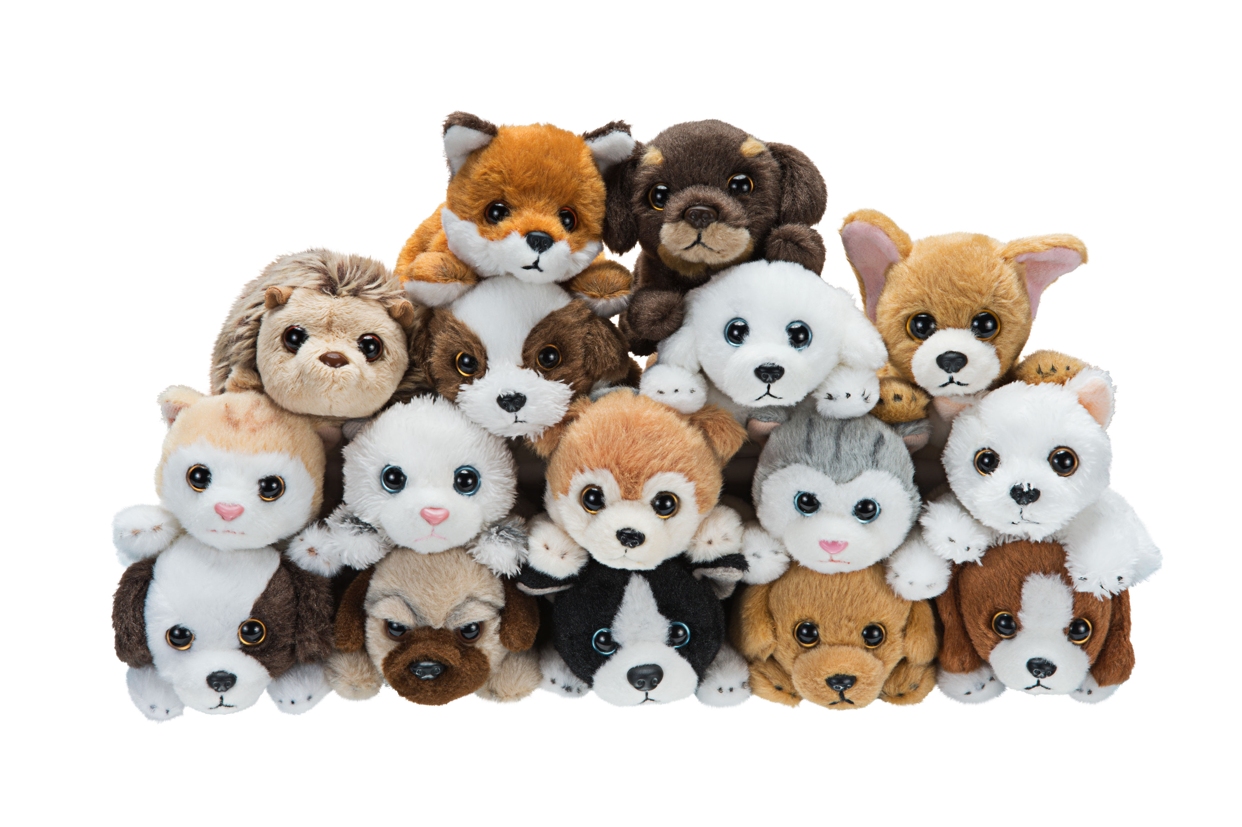
There is a litter of brand new collectable plush animals. Petooties Pets™ are realistic, four-inch animals that are playful, cuddly and fiercely loyal – from a Dalmatian to a Pomeranian, a Shih Tzu to a Himalayan Cat, Petooties are ideal for encouraging imaginative play.

- Adorable, ultra-soft, realistic looking mini-sized stuffed animals
- Cute, curious, bold, playful, friendly and fiercely loyal
- Collect, cuddle, stack and display

These cute mini pets fit in your pocket, backpack or tote, and are the perfect companion on the go. Collect and stack them all for lots of furry fun.

MSRP: $3.99
SIZE: Four (4) inches
AGES: 3-7 years (but suitable for kids and collectors of all ages)
RETAIL: Major retailers. TBA

Media Contact:
Dan Grody (for Kellytoy, Inc.)
Tellem Grody PR
310-313-3444 x3
dan@tellemgrodypr.com

